Create buildroot for VAR -DART 6UL

I uploaded
http://variwiki.com/index.php?title=Yocto_Build_U-Boot&release=RELEASE_ROCKO_V1.0_DART-6UL

and

http://www.variwiki.com/index.php?title=Yocto_Build_Linux

My def config us 6ull and not 6ul

I know it because I saw the original SD card the fdt_file variable in u-boot

so I uploaded both to my github to be able to pull them both in buildroo.

Kernel

When configuring the kernel , four things are needed

1. The githib repo of the board – its BSP
2. The lass commit value
3. the right def config of the board
4. its DTB

gatthering this information will build you the kernel for your board.

In the image bellow we can see the kernel configuration for var dart 6ull varicsite imx board.
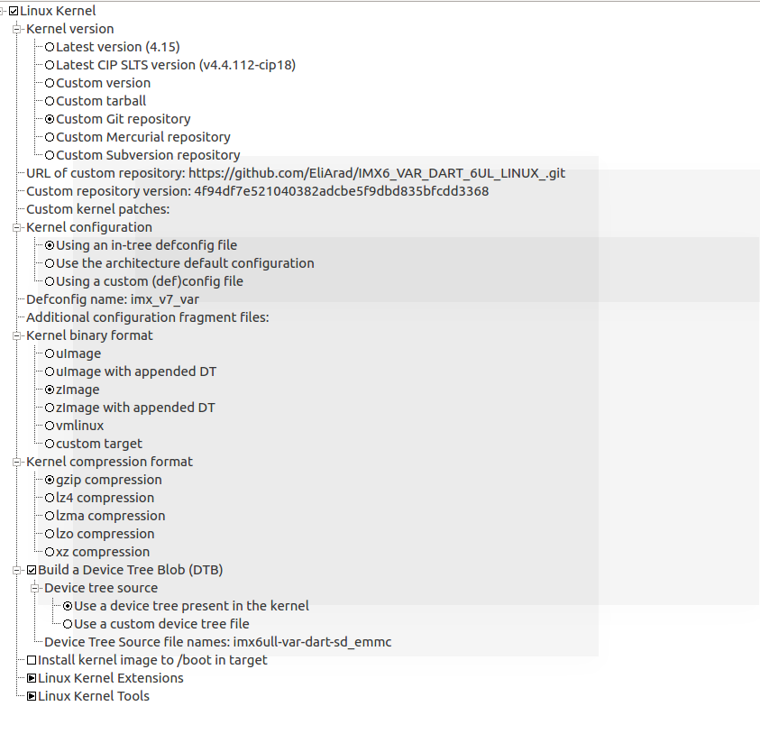

U-boot

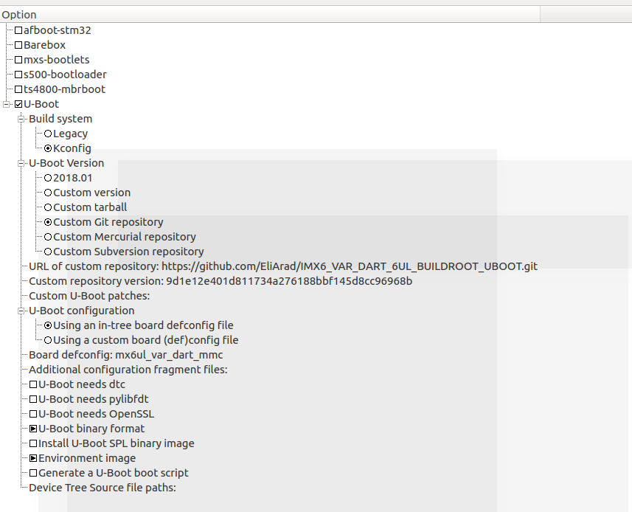
U-boot is also being taken from my github.
I follow the instructions on the build uboot from sources and uploaded the u-boot to my git because if want to let buildroot download it and built it from there.

Choose u-boot binary format as .img

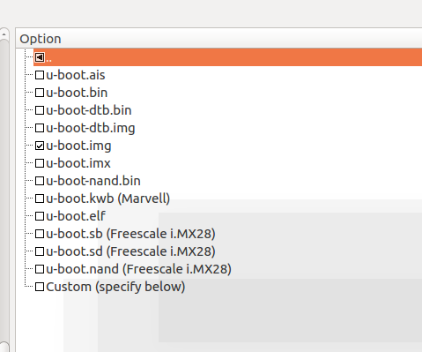

The image is created ok with the parameters ( git repository, commit number)
the only problem is the creation of the image

This is describe in the post build script

The post script

The port script builds the image

board/freescale/common/imx/post-image.sh

for u-boot there are two scripts:

./board/freescale/common/imx/genimage.cfg.template_spl
and

./board/freescale/common/imx/genimage.cfg.template

depends if we choose SPI or not.

Currently I dont know how to change the buildroot script to do the same as needed by var dart u-boot.

The image is built correct , altough the size is slight different but the u-boot.img is correct.

So from the file:

./board/freescale/common/imx/genimage.cfg.template

I commented out the u-boot partition.

image boot.vfat {
vfat {
files = {
%FILES%
}
}
size = 16M
}

image sdcard.img {
hdimage {
}

# partition u-boot {
# in-partition-table = "no"
# image = "u-boot.bin"
# offset = 1024
# }

partition boot {
partition-type = 0xC
bootable = "true"
image = "boot.vfat"
offset = 8M
}

partition rootfs {
partition-type = 0x83
image = "rootfs.ext2"
}
}

it means that the sdcard.img will not be built with the u-boot.img.

The sdcard image will need to be prepare with two stages.

First using etcher we will build the partitions.

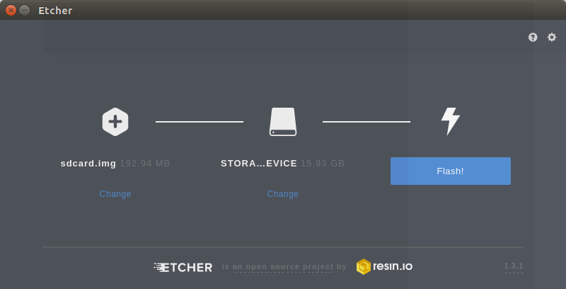

When finished we need to ran a copy_boot script I wrote that will copy the u-boot.img
and the dtb file.

Dont Eject the sd card yet and run the copy_boot script

sudo cp output/build/uboot-9d1e12e401d811734a276188bbf145d8cc96968b/SPL output/images
sudo cp output/build/uboot-9d1e12e401d811734a276188bbf145d8cc96968b/SPL.log output/images

sudo sshpass -p 'yourpass' dd if=SPL of=/dev/sd$1 bs=1K seek=1; sync
sudo sshpass -p 'yourpass' dd if=output/images/u-boot.img of=/dev/sd$1 bs=1K seek=69; sync

sudo sshpass -p 'yourpass' mount /dev/sd$11 /mnt/VARBOOT
sudo sshpass -p 'yourpass' mount /dev/sd$12 /mnt/VARROOTFS

sudo sshpass -p 'yourpass' cp output/images/imx6ull-var-dart-sd_emmc.dtb /mnt/VARBOOT/

sshpass will help your not to enter the sudo password

and the script will need the sd dev letter

Make sure it is not your hard drive or your usb drive!!!

The SPL and SPI.log also needed to be copied.

The information how to burn the u-boot can be found here:
http://www.variwiki.com/index.php?title=Yocto_Build_Linux

To summarize:

Instead of changing the buildroot sdimage creation I am using two stage scripts.

We can copy the changes of the image , for example if the root fs changes by copying the rootfs or repeat the stages above

1. make
2. Etcher the sccard.img
3. copy_boot - to fix the u-boot partition

